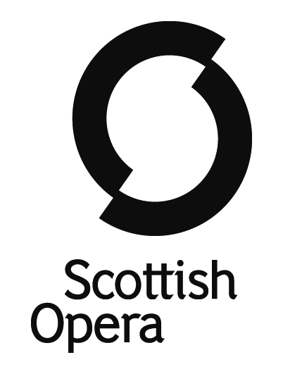

The Orchestra of Scottish Opera

Music Director – Stuart Stratford
Leader – Anthony Moffat

Section Principal 2nd Violin

Salary – £754.41 per week plus benefits

Scottish Opera takes world-class opera to all corners of Scotland and beyond, ensuring that as many people as possible can enjoy this wonderful art form. The company is Glasgow based and the Orchestra performs main stage and medium-scale operas, participates in education and outreach work and performs concerts and recordings.

We invite applications for the position of Section Principal 2nd Violin. Players have a contractual guarantee of a minimum of 29 weeks of work per year, and in November each year receive
5 months’ notice of their contracted weeks of work for the year that commences from April.

Auditions for this position will take place in Glasgow and London on the following dates:

1st Round (Panel to listen to Audio Visual Recordings – Screened)
Thursday 13th June 2024

2nd and 3rd Rounds (in person) – GLASGOW & LONDON
Tuesday 6th August 2024 GLASGOW (2nd round in the AM and 3rd round in the PM)
Thursday 15th August 2024 LONDON (2nd round in the AM and 3rd round in the PM)

All candidates must be able to demonstrate a pre-existing right to work in the UK and documentary proof of this will be requested prior to auditions.

Applicants should apply via Musical Chairs www.musicalchairs.info. To be considered for an audition, your application must include all of the documents specified on the Musical Chairs Website. If you have any queries regarding your application, please contact our Orchestra Manager, Heather North at heather.north@scottishopera.org.uk
The closing date for applications is Friday 31st May 2024 at 5pm, after which the panel will select candidates from the anonymised ATS profiles to go through to the 1st round.
We have a strong commitment to promoting equality, and we particularly encourage applications from people who are under-represented in the performing arts. To eliminate any unconscious bias, we have introduced an anonymised application process together with anonymised audio recordings. We do however require an AV recording for administrative purposes only. Please refer to our Submission guidelines for further information.

Scottish Opera strives to be an equal opportunities employer and is subsidised by the Scottish Government. Registered Number SCO37531. Scottish Charity Number SCO19787

