

CBSO Orchestral Residency
Tenor Trombone
Round 1 Audition Requirements

Please upload 1 video file containing the following audition material (in the order printed) to the file upload section of the application form on MusicalChairs.

- Own choice piece (or extract of) – up to 3 minutes
- Rossini - William Tell – letter C to nine bars after D
- Saint-Saens - Symphony No. 3 – Letter Q until second bar of S

The application and video submission are anonymous, the panel will hear the audio only. Please record all material unaccompanied. Candidates do not need to adhere to any pencilled markings printed in this booklet.

We understand that candidates may have varying access to recording technology so your submission will not be judged on audio quality. However, you may find the following recording guidelines useful.

Guidelines for Recordings
- A camera app on a smartphone is sufficient – we do not expect professional quality recordings.
- Ensure you are a sufficient distance from the microphone on your device to not distort the sound - 2-3 meters is recommended.
- Please do not speak in your recording – this audition round is anonymous.
- Please do not alter the audio in any way.

If you have any questions, please contact Chris Goodchild (Assistant Orchestra Manager) at cgoodchild@cbso.co.uk.

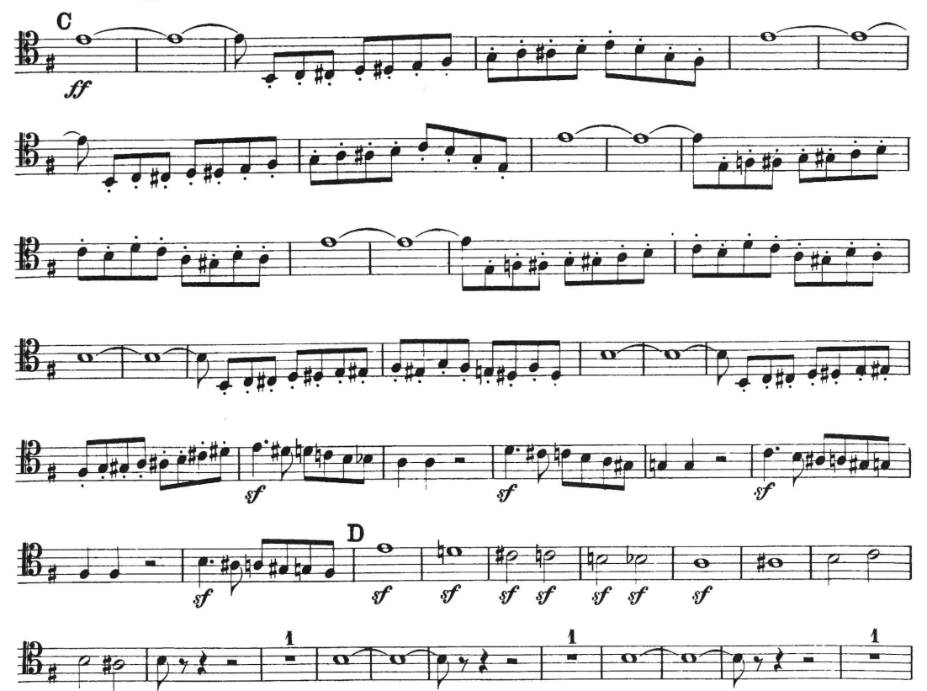
William Tell – letter C to nine bars after D (part 1)

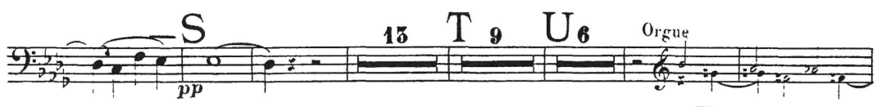
Saint-Saens - Symphony No. 3 – Letter Q until second bar of S (part 1)
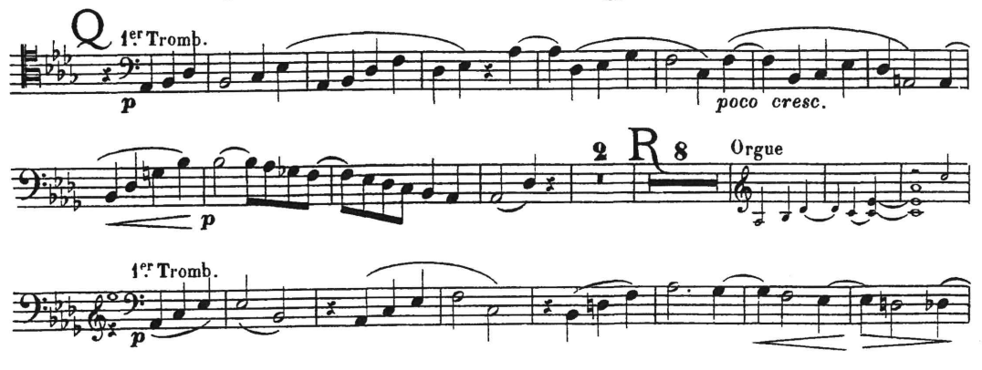
Round 2 Audition Requirements

If you are selected for Round 2, please prepare the following material, in addition to the material from Round 1.

- Mahler Symphony No.3, 1st movement (2 excerpts)
- Ravel – Bolero
- Sibelius – Symphony No.7, 1st movement
- Stravinsky – The Firebird Suite, Infernal Dance (2 excerpts)

Round 2 auditions will not be screened and will be heard unaccompanied. Candidates do not need to adhere to any markings that appear in this booklet.

If you have any questions, please contact Chris Goodchild (Assistant Orchestra Manager) at cgoodchild@cbso.co.uk.

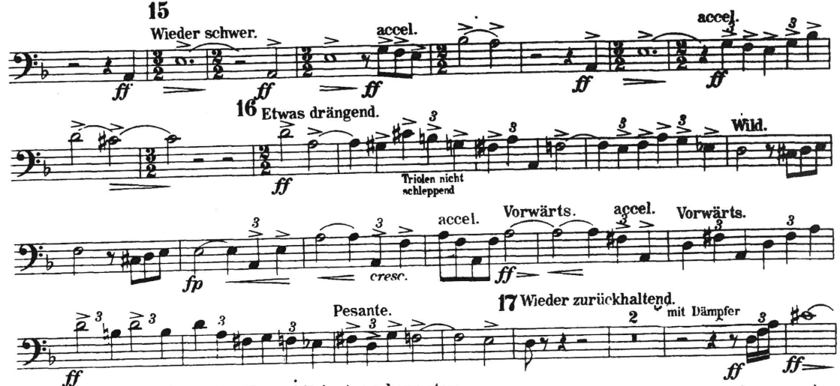
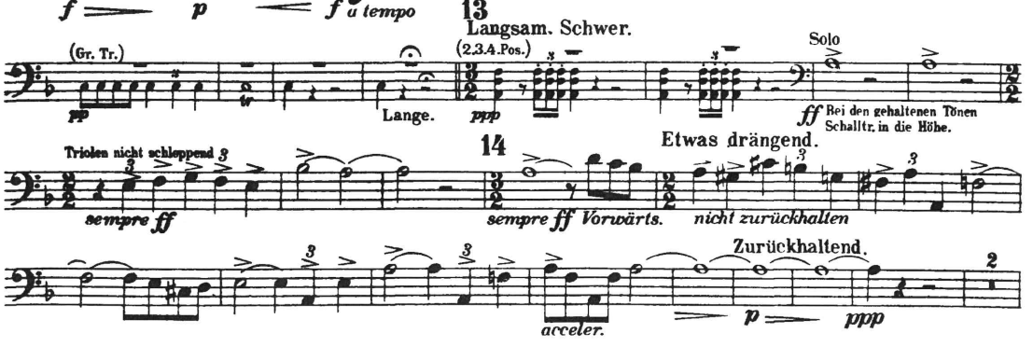
Mahler - Symphony No.3, 1st movement – Figure 13 to Figure 17

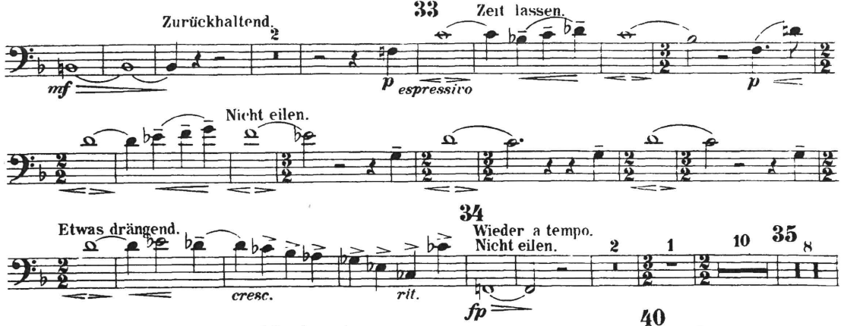
Mahler Symphony No.3, 1st movement –Figure 33 to Figure 34
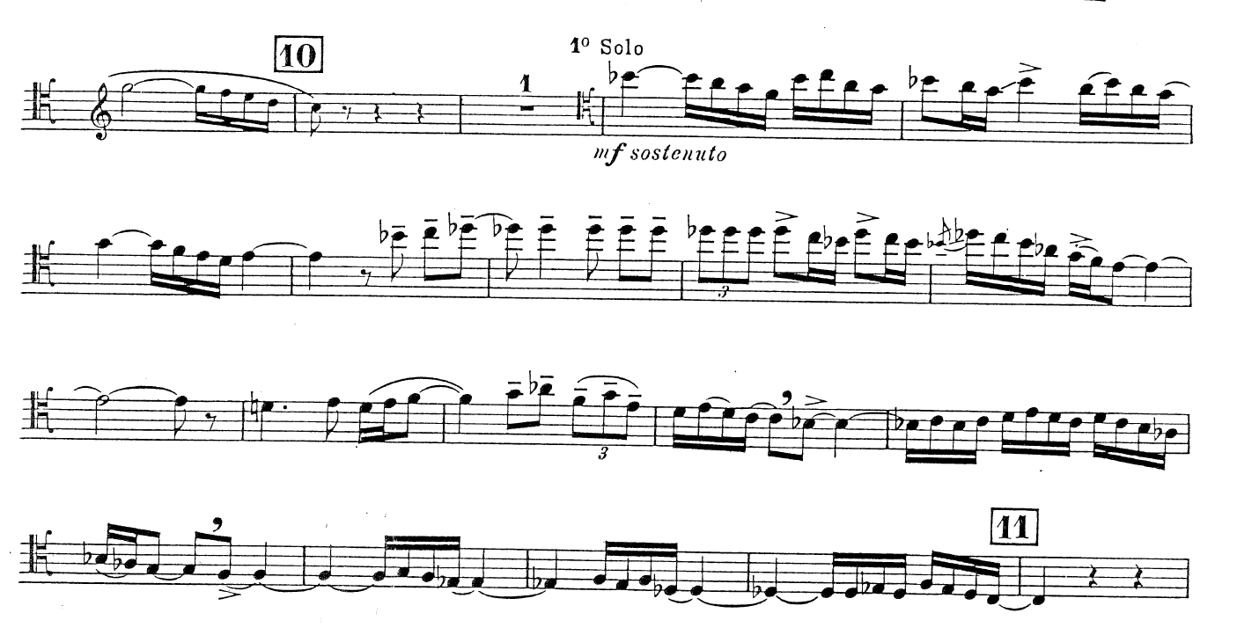
Ravel - Bolero

Sibelius – Symphony No.7, 1st movement
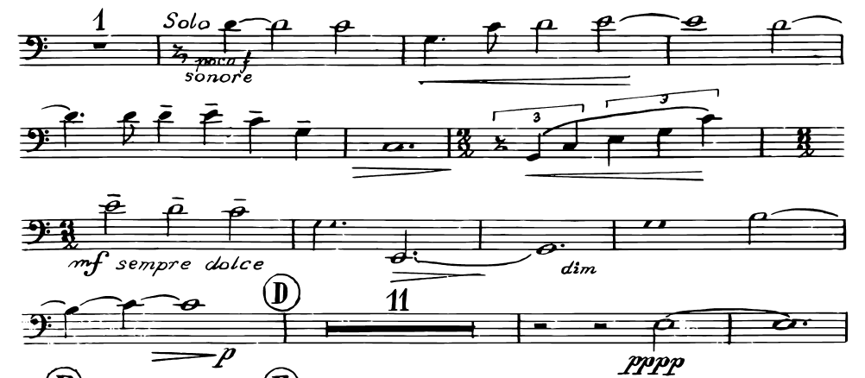

Stravinsky – The Firebird Suite, Infernal Dance
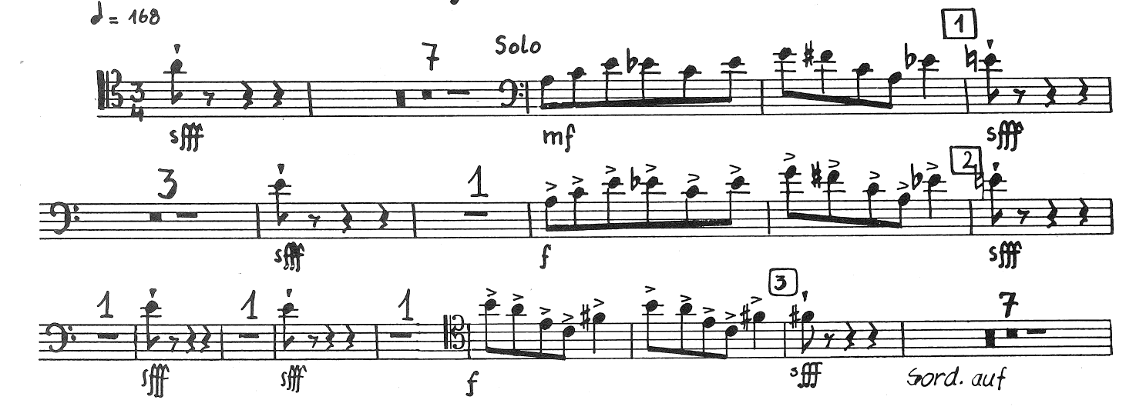
Start – Fig.3

Fig.10-14
