**AUDITION FOR CONCERTMASTER POSITION**

**22 & 23 SEPTEMBER 2025**

This audition is open to candidates of all nationalities.

All candidates must meet the following general requirements:

* Provide proof of civil status
* Enjoy full civic rights
* Be declared medically fit for the profession of musician.

Employment under an open-ended contract (with a three-month probationary period, renewable once). Expected start date: early 2026

Salary (non-categorised position): €5,322.44 gross per month, for an annualised workload of 50 hours per month

## Concertmaster Position

The Concertmaster is the primary point of contact with the Music Director for all matters concerning the artistic life of the orchestra, and is responsible for maintaining the ensemble’s artistic discipline.

The Concertmaster leads and oversees the artistic work of the violin section, the string section as a whole, and the orchestra, in collaboration with the conductor, in pursuit of the finest musical interpretation. The Concertmaster is responsible for bowings and markings for the principal string parts.

The two Concertmasters of the Orchestre de Chambre de Paris work in close harmony, maintaining regular dialogue with each other and with the Music Director to ensure a balanced and complementary artistic contribution. In addition to their central artistic role, the Concertmaster performs highly virtuosic repertoire as principal violinist—whether symphonic, chamber, or as a soloist—and may also lead the orchestra in Play-Direct (conductor-less) programmes.

Possessing an open mind and keen awareness of the professional musical world, the Concertmaster takes initiative in the pursuit of excellence and the ongoing artistic development of the ensemble, working in close consultation with the Music Director. They also participate in key organisational bodies such as the Artistic Committee, recruitment auditions, and tenure review panels, etc.

Submission of a completed application form is mandatory. It must include the following information:

Full name – Date and place of birth – Nationality – Address – Email address – Phone number – Education – Previous and current employment.

A CV may be attached.

Applications must be submitted via the registration form available on our website <http://www.orchestredechambredeparis.com/recrutement/>

Or by post to:

Orchestre de chambre de Paris *Service concours de recrutement* 221, Avenue Jean Jaurès

75019 Paris France

## Applications must be received by 08 September 2025

## DATE AND LOCATION OF THE AUDITION:

The audition rounds will take place on September 22 (1st round) and September 23 (2nd round and final), starting at 9 AM (exact schedule to be confirmed later by official summons) at the Philharmonie de Paris, Artists’ Entrance, 191 Boulevard Sérurier, 75019 Paris. (See access map.)

All candidates are required to arrive at the same time for a random draw determining the order of performance.

The jury reserves the right to refuse any candidate who arrives late (after the scheduled call time).

Candidates are responsible for their own travel and accommodation expenses, as well as those related to rehearsals with the accompanist pianist (each candidate may choose to be accompanied by a pianist of their choice).

The audition rules are available at [www.orchestredechambredeparis.com/recrutement](http://www.orchestredechambredeparis.com/recrutement)

**Map**

**Metro** Line 5 Porte de Pantin station: Direct from Gare du Nord (5 stations) and Gare de l’Est (6 stations).

**Tram T3b** Porte de Pantin station

**Bus** Lines 75 - 151

**Night buses** (**Noctilien)** N13 - N41 - N45 - N140

**Bike sharing** (**Vélib’)** 210, avenue Jean-Jaurès Paris 19 | 3, place de la Porte de Pantin Paris 19

**Car sharing (Autolib’)** 8 rue Adolphe Mille Paris 19| 9 rue des Sept Arpents Paris 19

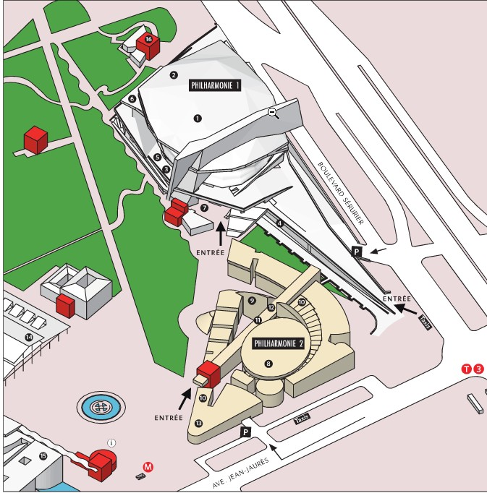

**ARTISTS’ ENTRANCE:**

191 Boulevard Sérurier 75019 Paris