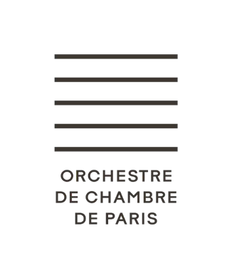

**AUDITION FOR CONCERTMASTER POSITION**

**22 & 23 SEPTEMBER 2025**

# PROGRAMME

**FIRST ROUND** (Behind screen)

Concerto of your choice (Bärenreiter edition)

W.A. MOZART - Concerto No. 4 or No. 5 1st movement with the cadenza of your choice

Orchestral excerpt:

R. SCHUMANN - Symphonie No. 2 Scherzo, from the beginning up to bar 54 (including the repeat)

## SECOND ROUND

Concerto of your choice

R. SCHUMANN - Violin Concerto 1st movement up to bar 221

L. VAN BEETHOVEN - Violin Concerto 1st movement up to bar 224 + cadenza and end of movement

F. MENDELSSOHN - Violin Concerto in E Minor 1st movement up to bar 351 (letter K)

C. SAINT-SAËNS - Concerto No. 3 Op.61 Entire 1st movement

J. BRAHMS - Violin Concerto 1st movement up to bar 272 (letter E) + cadenza

1. DVORAK - Violin Concerto 1st movement up to bar 216 (letter G)

Solos

J.S. BACH - Mass in B Minor ‘Laudamus Te’ (complete)

1. BARTOK - Divertimento 3rd movement: bars 248 to 316

## THIRD ROUND - WITH ORCHESTRA

With the orchestra conducted by Thomas Hengelbrock:

L.VAN BEETHOVEN - Symphony No. 4 1st movement: Adagio - Allegro vivace up to bar 198

R. STRAUSS - Le Bourgeois Gentilhomme No. 4: *Auftritt und Tanz der Schneider* (complete)

Play-Direct working session (conductor-less)***

W.A. MOZART - Symphony No. 41 ‘Jupiter’ 2nd movement: Andante cantabile up to bar 44

4th movement: Molto Allegro up to bar 157

# INFORMATION

* The orchestral excerpts must be downloaded from the Orchestre de Chambre de Paris website <http://www.orchestredechambredeparis.com/recrutements/>
* Each candidate must bring their own sheet music and piano accompaniment scores on the day(s) of the audition.
* All auditions will be performed at the orchestra's tuning standard: A4 = 442 Hz.
* All pieces may be performed or repeated during any round. The jury reserves the right to interrupt the candidate, during any round, at any moment in performance. Conversely, if deemed useful, the jury may request an additional audition. All rounds are eliminatory. The jury’s decisions are final.

*** Play-Direct working session:

**In this session, the candidate must both play and direct the orchestra from the concertmaster’s chair, guiding the rehearsal and shaping the musical result. The candidate will have approximately 20 minutes to lead this session. The chair of the jury may also contribute by offering suggestions.**